Overview of QPG6200L Peripherals
The QPG6200L is a multiprotocol system on chip designed for IoT applications featuring a set of peripherals optimized for connectivity, sensing, user interaction, and power efficiency. These peripherals are configurable with flexible mapping to IO pins and are retained across sleep modes to minimize reconfiguration overhead. The chip includes 14 programmable GPIO lines (expandable to up to 17 input/output +4 input only by repurposing other pins), 2 analog IO (ANIO) lines, and a 16-channel DMA engine that offloads data transfers between RAM and peripherals, reducing microcontroller involvement.

Peripherals are divided into general purpose IO, analog sensing, user interface elements, audio interfaces, timers, and communication interfaces. Many support low power operation, hardware acceleration, and integration with the ARM Cortex-M4 microcontroller (running up to 192MHz).

- IO Pins
The QPG6200L's IO pins form the foundation for peripheral connectivity, allowing flexible mapping of signals to physical pins. Configurations are retained during sleep modes for seamless wake-up.
- Total Pins and Types:
  - 14x programmable GPIO lines
  - 2x ANIO lines for analog signals
  - Optional expansions: Up to 7 more GPIO lines by swapping pins (e.g., from ANIO, DC/DC converter, LPBIAS, or 32 KiHz crystal), with 4 of these being input-only
  - Maximum: 17x GPIO + 4x Input only
- Configuration Details :

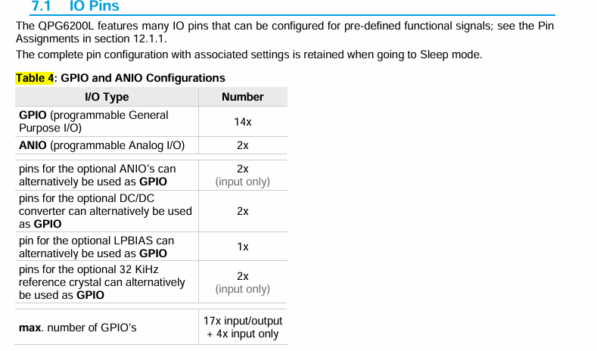
- Mapping and Retention: Pins can be assigned to predefined functional signals (see pin assignments in section 12.1.1 of datasheet). All configurations (e.g., pull modes, drive strength) persist through sleep states, ensuring no reconfiguration is needed on wake-up.
- GPIO
GPIO lines are the most versatile peripherals, mappable to various functions like timers, PWM, or interfaces.
- Numbers and Mapping: 14 standard lines, individually mapped to signals (e.g., via software configuration). See pin assignments in Tables 37 and 38 of the datasheet.
- Configuration Options:
  - Pull-up/Pull-down Modes: Most pins support floating (no pull), pull-down, or pull-up. Exceptions: GPI25 and GPI26 are always floating. Default at power-up/reset: Floating. Weak pull-up/down available in active and sleep states.
  - Wake-up Capability: All except GPIO19 and GPIO20 can trigger wake-up on rising edge, falling edge, or both.
  - Drive Strength: Configurable per output to 2 mA, 4 mA, 8 mA, or 12 mA (applies to standard input/output GPIOs only, not input-only).
  - High Drive Sink (GPIO0 Only): Enables a high-drive MOSFET N-Type sink for driving high-power circuits like IR LEDs. Example circuit: Connect IR LED with resistor to Vext, using GPIO0 as sink (Figure 3). Without it, a standard GPIO drive is used (Figure 4), but high-drive allows higher current for brighter/more distant IR transmission.
- Operational Notes: GPIOs integrate with DMA for efficient data handling. In sleep modes, they retain state and can trigger wake-ups without microcontroller intervention.
- ANIO/ADC
Dedicated for analog signal monitoring with flexible multiplexing,
- ANIO Lines: 2 programmable lines for external analog inputs
- ADC Types
  - High-resolution 16-bit ADC: For precise measurements.
  - General Purpose 11-bit ADC: For standard applications.
  - Low-power Comparator (LPCMP): For threshold-based comparisons.
- Switch Matrix (MUX) Full MUX connects any ANIO to any ADC or LPCMP. Supports differential measurements by combining ANIOs
- Accuracy and Characteristics
  - 16bit ADC: High precision for applications like sensor readings.
  - 11-bit ADC: Balanced for general use.
  - See Figure 5 for connect options: ANIOs route to 11-bit ADC, 16-bit ADC, or LPCMP via MUX.
- Integration: Can be used with battery/temperature monitor. DMA Support for automated data transfer
- Battery/Temperature Monitor
Integrated monitoring without external components using the ADC module.
- Functionality: Software configurable to measure power supply voltage (VBAT) and internal temperature separately from ANIO pins
- Characteristics:
  - Measures VBAT level internally
  - Temperature sensor for on chip monitoring
- Use Cases: Low-voltage detection, thermal management in IoT devices. Integrates with wake-up events or interrupts for alerts
- Keyboard Scanner
Hardware accelerated for low power key matrix scanning
- Matrix size: 8x8 with ultra low power wake up on key press
- Features:
  - Scan triggered by IO change (key press) or timed event (de-bouncing)
  - Hardware de-bounce and scan
  - Software configurable mapping of physical row/column to logical keys.
- Dependencies: Max columns/rows depend on enabled GPIO devices (Table 37/38). DMA capable for key data transfer
- Power Efficiency: Wake up from sleep on press minimizing polling
- IR Generator
Dedicated for infrared remote control protocols.
- Modulation Modes:
  - Pattern based: Input as 0/1 pattern in RAM
  - Time based: Sequence of ON/OFF times
  - Event based: Controlled by schedule actions
- Support: Wide range of common IR protocols (NEC, RC5). Carrier and modulation parameters software defined.
- Integration: Uses GPIO0’s high drive sink for high power IR LEDs. DMA for pattern data.
- LED Generator
For signaling LEDs with power saving features
- Support: Up to 4 signaling LEDs, configurable functions/events
- Features:
  - 8 bit PWM for brightness control
  - Fade in/out transitions
  - Duty cycling to adjust brightness and reduce power
- Use cases: Status indicators in wearables or sensors
- LED Pixel Protocol Master (RTZ)
Two masters for controlling LED strips (e.g., WS2812/Neopixel)
- Protocol Support: Return to Zero (RTZ) for many commercial LED pixel ICs
- Features:
  - Sequential (Neopixel) or random addressing
  - Highly configurable for various protocols
  - Efficient RAM usage for pixel frames; sends frames without MCU intervention
- Number: 2 independent master
- PWM Engine
Advanced pulse width modulation for digital MEMS microphones
- Conversion: From 1 bit PDM to 16 bit PCM
- Features:
  - Clock and data pins per interface
  - Optional stereo: Capture on rising/falling clock edges
  - Configurable clock: Default 2 MHz; synthesizer up to 3071 kHz
  - HW CIC decimation filter (r=1-64) for downsampling
- Integration: PCM output to DMA for further processing (decimation, EQ, volume, compression) via Cortex-M4 DSP
- PWM Engine
Advanced pulse width modulation for up to 8 channels
- Features:
  - Programmable frequency
  - Independent phase/duty cycle per channel
  - Arbitrary waveforms from RAM sequences
  - Glitch free parameter updates
- Use Cases: LED drivers, motor control. Assignable to GPIO pins
- Generic Timers
Flexible timers for timing and event generation
- Configuration: 6 32 bit or 12 16 bit (software selectable)
- Modes:
  - Prescaled: Counter runs from min clock with divide ratio
  - Count: Increments on events (e.g., external pin)
- Channels: 4 Capture/compare per timer for interrupts on match or capture on events
- Integration: With Event scheduler for just in time actions
- Communication and Interfacing Peripherals
These are detailed in section 8.8 for external device connectivity
- UARTs (3):
  - Full duplex, baud rates 488 Bd-2 MBd
  - Frames: 5-9 data bits, 1-2 stop bits, parity, error detection
  - Interrupts: TX Complete, TX Empty, RX Complete
  - Hardware flow control; flexible pin mapping
- USB Device:
  - USB 2.0 Full Speed (12 Mbit/s)
  - Bulk, interrupt, isochronous transfers
  - Double buffering; 1kB buffer, DMA; remote wake up
- QSPI Master:
  - For external memory (e.g., Flash)
  - Single/Dual/Quad SPI modes; up to 4 data lines + SCLK + SSN
- SPI Master:
  - Full-duplex on MISO/MOSI/SCLK
  - Modes 0-3; MSb/LSb first; up to 32 MHz; 4-16 bit frames
  - Interrupts: TX Complete, TX Empty, RX Complete
- SPI Slave:
  - Generic protocols + Qorvo DMA protocol
  - Mode 0; up to 16 MHz; byte based; flexible IO
- I2C Master (2):
  - Standard/Fast mode; 7/10 bit addresses; general call; clock stretching
- I2C Slave:
  - Standard/Fast mode; 7/10 bit addresses; configurable address; general call
- I2S Master/Slave (2):
  - Full duplex; configurable word length; left justified (right emulatable)
  - Master clock 62.5 kHz - 8 MHz; slave up to 4 MHz; double buffered; DMA
- SPI Programming interface: Uses SPI Slave for NVM programming; specific pin mapping (table 7); max 2.25 MHz SCLK
- Clock Output (2): Derived from 192 MHz clock; up to 96 MHz; for peripherals
- Additional System Peripherals
- DMA Engine: 16 Channels; transfers between RAM/peripheral without MCU
- Watchdog Timer: 16 bit, 16us resolution; configurable timeout (16us - 1s); actions (interrupt, MCU reset, POR); protected against accidental triggers.
- Event Scheduler: Adaptive timing engine; 1us resolution up to 30 min; schedules actions autonomously for energy efficiency

QPG6200L DataSheet
https://drive.google.com/file/d/1K-dKqGUvWg2dyH9Suz4KRsIPYQmgcV9i/view?usp=sharing

